**Testing PHP application with Selenium**

1. Running Selenium in Docker Container  
   **URL: http://** [**http://18.191.10.210:9999/**](http://18.191.10.210:9999/)

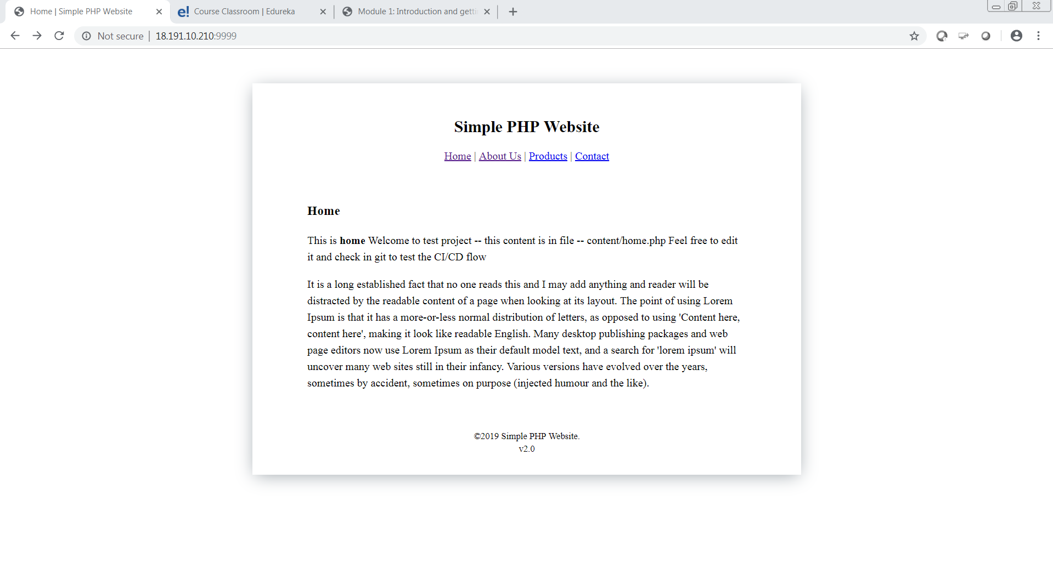

1. Selenium Java Script to verify the text in “**About Us**” Hyperlink  
     
   Text in “About Us” before running selenium

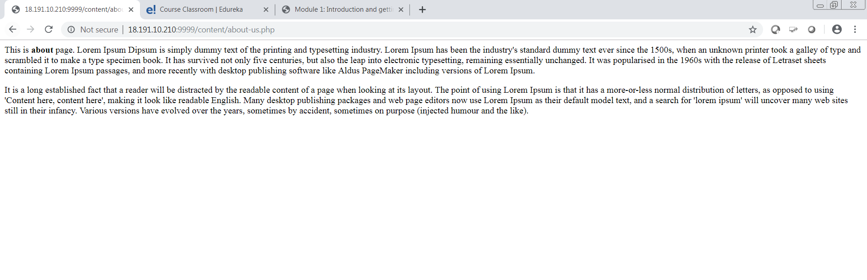

1. Selenium java script to perform testing in above PHP application.

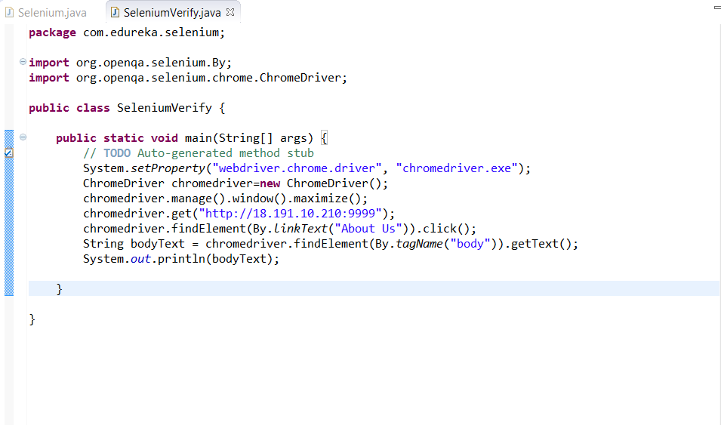

1. After running the script

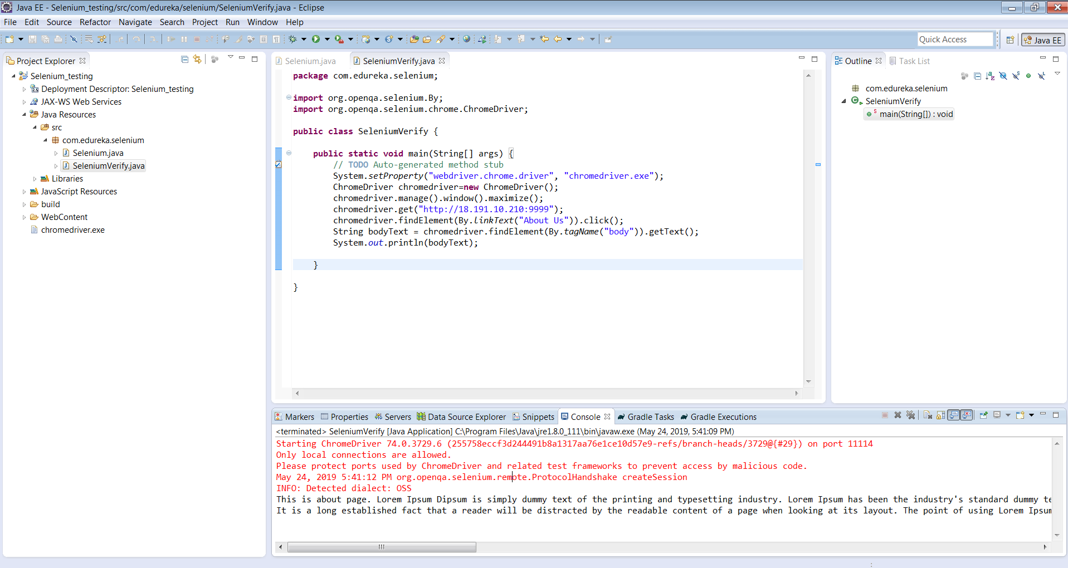

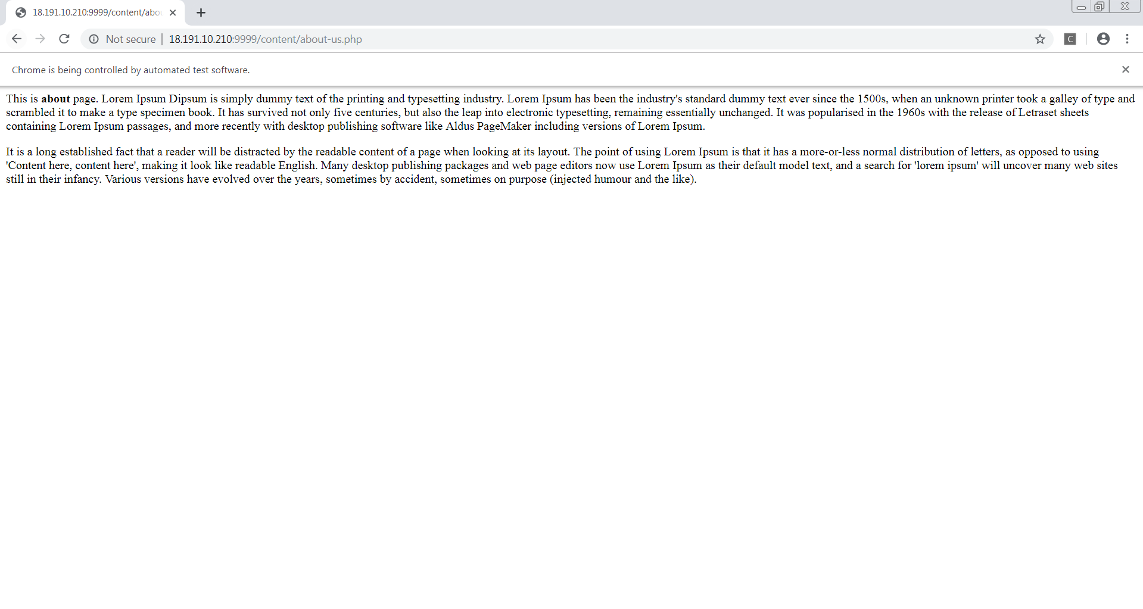  
**Selenium Code:**  
  
**package** com.edureka.selenium;

**import** org.openqa.selenium.By;

**import** org.openqa.selenium.chrome.ChromeDriver;

**public** **class** SeleniumVerify {

**public** **static** **void** main(String[] args) {

// **TODO** Auto-generated method stub

System.*setProperty*("webdriver.chrome.driver", "chromedriver.exe");

ChromeDriver chromedriver=**new** ChromeDriver();

chromedriver.manage().window().maximize();

chromedriver.get("http://18.191.10.210:9999");

chromedriver.findElement(By.*linkText*("About Us")).click();

String bodyText = chromedriver.findElement(By.*tagName*("body")).getText();

System.*out*.println(bodyText);

}

}